Edit Distance Between Two RNA Structures
Guo-Hui Lin, Bin Ma Kaizhong Zhang
Research in Computational Molecular Biology, 211-220 (2001)
Abstract
Arc-annotated sequences are useful in representing the structural information of RNA sequences. In this paper, we propose the notion of edit distance to measure the similarity between two RNA secondary and tertiary structures, by incorporating the various edit operations performing on both bases and arcs.
- Introduction
We use EDIT(TYPE1,TYPE2) to denote the Edit Distance Problem for Arc-Annotated Sequences. Notice that there are three possible types of arc structure: crossing, nested, and plain, from high complexity to low. EDIT(crossing, plain), EDIT(crossing, crossing) and EDIT(crossing, nested) are MAX-SNP-hard. We’ll give an approximation algorithm with worst-case performance ratio max{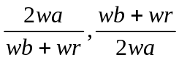}

- Method
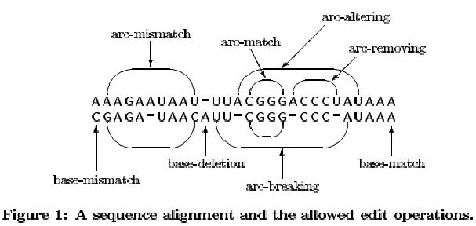
- Dynamic Programming for EDIT(nested, plain)
Suppose in the given instance of EDIT(nested, plain), the pair of sequences are (S1,P1) and (S2,Ø). Let DP(i, i’; j, j’) denote the edit distance between the pair of partial sequence (S₁[i, i’],P1[i, i’]) and (S₂[j, j’], Ø)
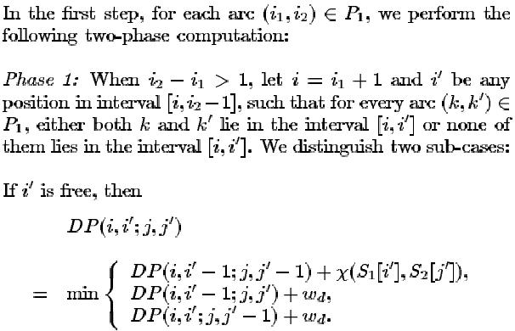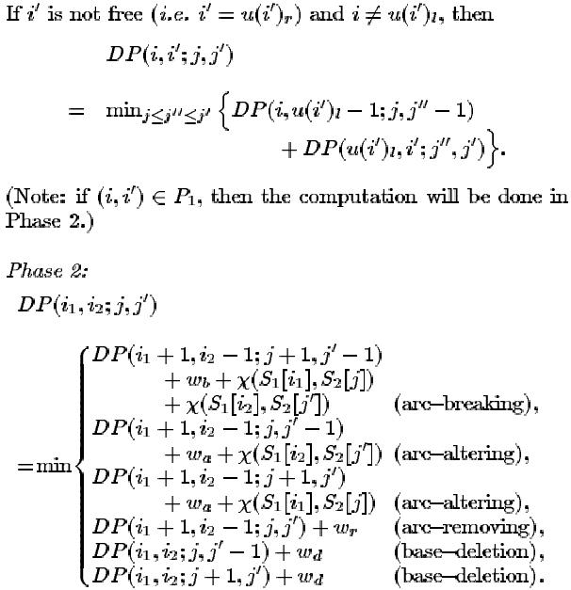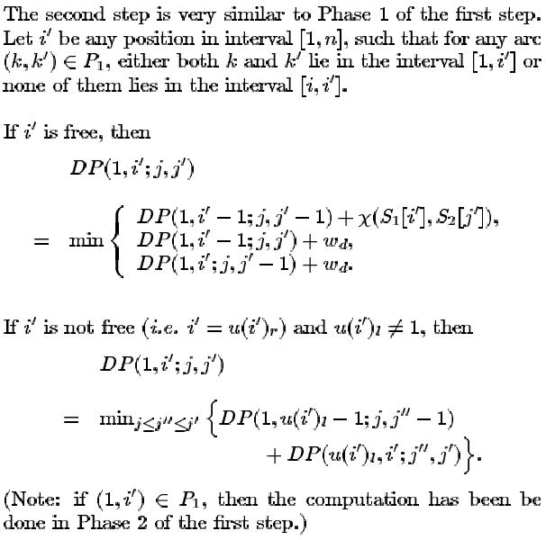
Entry DP(1,n;1,m) records the answer
EDIT(nested, plain) is solvable in time O(nm³)

- DP for EDIT(crossing, nested) (solvable when 2w_{a} = w_{b} + w_{r})
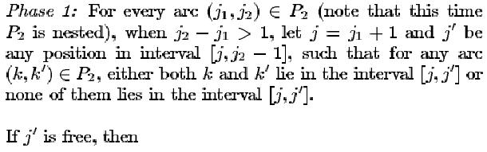

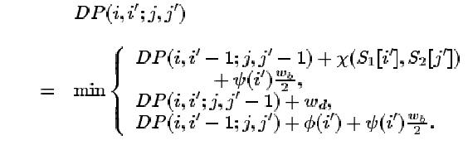

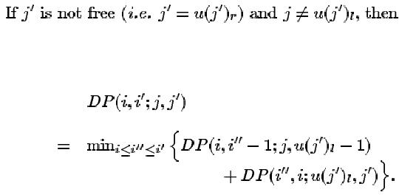

In the second phase, we discuss the following two case
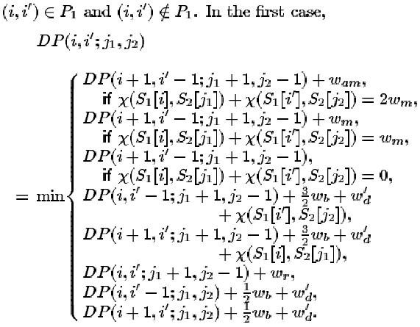

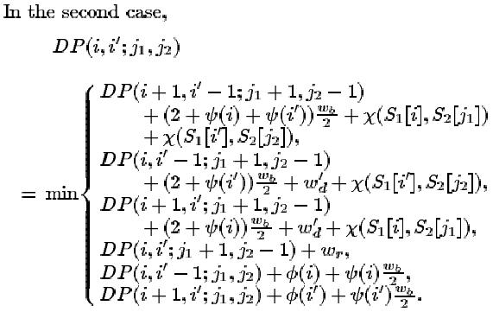

When 2w_{a}=w_{b}+w_{r}, EDIT(crossing, nested) is sovable in O(n³m)
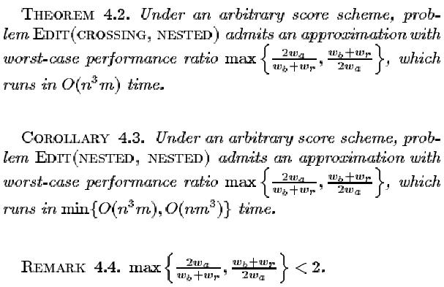

Created by : Yung-Hsing Peng
Date : Oct. 31, 2003

